Sukkur IBA University

Kandhkot Campus

**Software Requirement Specification (SRS)**

**For**

**YHEW Food Delivery Mobile Application**

By Sooraj Kumar

Supervisor:

Muhammad Faiz Lakhani

Contents

**Introduction** **3**

1.1 - Purpose of this Document 3

1.2 - Intended Audience 3

1.3 - Document Convention 3

1.3 - Project Scope 3

1.4 - Not in Scope 4

**Overall System Description** **4**

1.6 - Project Background 4

1.7 - Project Objectives 4

1.8 - Stakeholders 4

1.9 - Operating Environment 5

1.10 - System Constraints 5

1.11 - Assumptions & Dependencies 6

**External Interface Requirements** **6**

2.1 - User Interfaces 6

2.2 - Hardware Interfaces and Software Interfaces 6

2.3 - Communication Interfaces 7

**Functional Requirements** **7**

3.1 - Functional Hierarchy 8

3.2 - Use Case Diagram 9

**Non-functional Requirements** **9**

4.1 - Performance Requirements 9

4.2 - Safety Requirements 10

4.3 - Security Requirements 10

4.4 - User Documentation 10

# **Introduction**

## 1.1 - Purpose of this Document

The Purpose of this document is to provide the description of my project named “YHEW Food Business App” in detail. This document gives a thorough insight and knowledge about the project with its objectives, interfaces, operations and scope so as to make this understandable to be used. Moreover, this document also includes the features of the project and its constraints and also states the information about the stakeholder who are involved either directly or indirectly with this project. It also provides a list of requirements (test cases) against which this project final version can be tested and from which it can be determined whether I am able to successfully implement the system according to the design framework.

## 1.2 - Intended Audience

The SRS document is intended for all the stakeholders to confirm on all the requirements and features before submitting the FYP. Stakeholders include my supervisors and FYP Committee. The document states project scope with detailed explanation of features and specifications. It will help for all the users to understand about the project and FYP Committee to prepare testing cases accordingly. The document also includes some limitations and constraints and the operating requirement in which the system would work.

## 1.3 - Document Convention

The main purpose of the app is to order Home-made food. There are multiple features of the app which are divided in subsystems like managing products and managing orders, profile approvals by admins. I have used the Times New Romans font with standard size of 12 for normal text and 14 for the headings.

## 1.3 - Project Scope

The goal for developing this app is to create convenience for customers to save their time by providing them home-made food on a daily basis. Moreover, there are many other options which make ordering and food selection feasible for the customers.

The project will be divided into three phases:

Phase 1: Initial Phase: Basic YHEW App on Single user

Phase 2: Order Placement and Order Management (for sellers and Admins)

Phase 3: MultiVendor Profile Management

## 1.4 - Not in Scope

This project isn’t the full premium marketplace like Amazon or so. This is the App which is a small marketplace for buying and selling Home-made food. Integrating banks or any Payment gateway is not part of the FYP Project.

# **Overall System Description**

## 1.6 - Project Background

I am working on a mobile application which provides an opportunity for females to earn bachelors to eat healthier home-made food. It can benefit the overall youth. Research finds that people who eat home-cooked meals on a regular basis tend to be happier and healthier and consume less sugar and processed foods, which can result in higher energy levels and better mental health. This application will empower millions of housewives to sell their food and earn their livelihood on their own. This will cover only the home-made food, no restaurants or junk food which is fulfilling the core purpose of this mobile application.

.

## 1.7 - Project Objectives

The youth has been depreciating junk food so much that it costs their health and makes them bear sickness in their early age. Job holders who live far from their home, have to eat junk food on a regular basis which affects their overall health. Meanwhile, females who couldn’t get education have very few or almost no resources to earn their own. Those females usually stay home, do house work and cook food. This App will help them earn by skills they have.

## 1.8 - Stakeholders

There are three major stakeholders in this YHEW business application.

* Customers,
* Seller
* Admin

**For Customers:**

* Browse through different menus and deals along rates.
* Customize the list according to the following criteria:
  + Food category
  + Budget
  + Ratings
* Place Your Order
* Leave Feedback
* Helpline/Call for Complain

**For Sellers:**

* Sellers will create their profile and wait for Admin approval
* Once a profile is approved, they can list their products.
* Sellers can create/edit/delete products
* Sellers can set the dynamic and static menus of food
* Take Order after accepting it with your consent
* Sellers can communicate with customers through messaging service
* Sellers can track earnings
* Sellers can make reports and see analytics

**For Admin:**

* Add new feature
* Manage multiple accounts
* Handle complains
* Send warnings to other users
* Approve Seller Accounts

## 1.9 - Operating Environment

This App is based on a cross platform framework which means that it can run on both android and ios. Before full app deployment, it will need good systems to run and show the output. It needs a high end system to run and manage this application.

## 1.10 - System Constraints

**System Constraints:** This App is based on location based results so the location permission is necessary for the app to run properly. It needs to know your location so that it can show you the results.

**Hardware constraints:** This App can run on mobile phones but not on computers. It can run on Android and iOS only. This can’t run on any other OS except the Android and iOS.

**Cultural constraints:** This App is based on English Language only so users who don’t know English will not be able to use this app.

**Legal constraints:** Not Applicable

**Environmental Constraints:** Not Applicable

**User constraints:** This app is designed for all people with no age or any other limitations.

## 1.11 - Assumptions & Dependencies

Internet-enabled mobile phones will be required to access the system. The memory usage of the app will have to be constrained by the devices it is intended to run. Since most tablets, Android phones may have limited memory.

# **External Interface Requirements**

## 2.1 - User Interfaces

There would be separate interfaces and options for sellers and buyers.

However, there will be consistency in the screen designs and the interface of the App following the proper branding.

* There shall be a fixed menu bar at the top with following buttons
* There should be fixed drop down menu pointer at top left with following options (Profile, Help, Settings, Logout)
* On clicking the logo, the system shall return to Home Page

The layout should be simple and easy to use. The layout should provide maximum user experience. In case of any errors, it should provide proper guidelines to resolve.

## 2.2 - Hardware Interfaces and Software Interfaces

We would require following technology for development of the app:

* GPS Enabled Device
* Mobile phone with Android 9 or above

Moreover, following technology stack can be used:

MySql database, Javascript and React Native for front end, NodeJS for backend, A cache such as

Memcached or suitable would be required to store data.

## 2.3 - Communication Interfaces

The system will use following communication interfaces:

* Text communication
* Protocols would be required for secure communication and message encryption

# **Functional Requirements**

## 3.1 - Functional Hierarchy

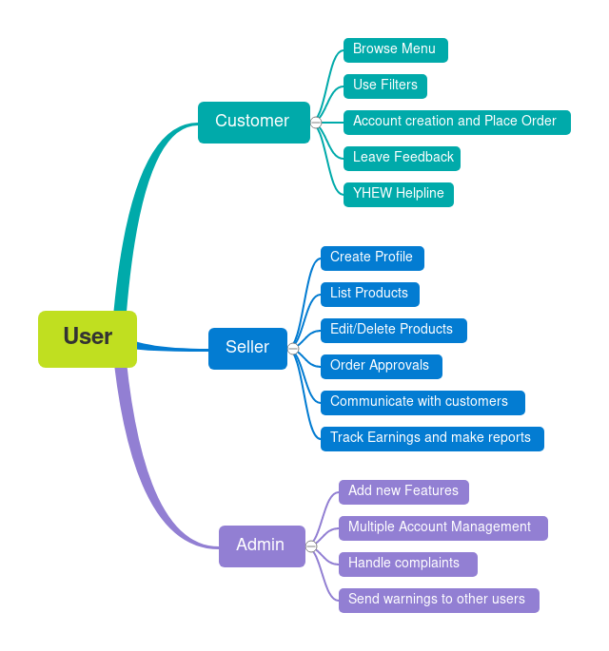

## 3.2 - Use Case Diagram

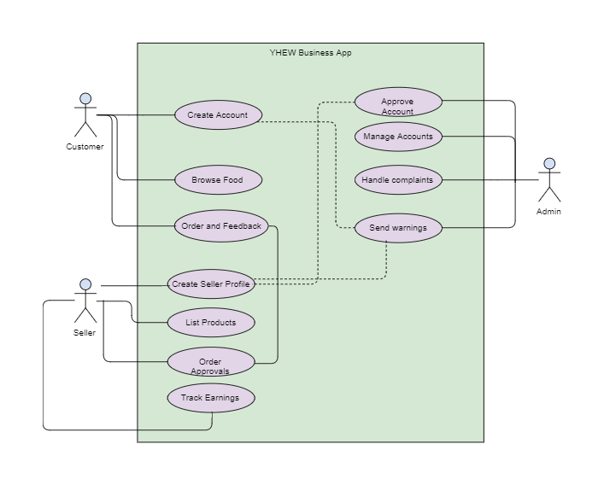

## 

## 

## 

## 

## 

## 

## 

## Use Cases

| **<Use case Id: Create Account>** | | | | |
| --- | --- | --- | --- | --- |
| **Use case Id:** | | UC-01 | | |
| **Actors:**  Customer, Seller and Admin | | | | |
| **Feature:** User will click on Signup Button | | | | |
| **Pre-condition:** | | Not Applicable | | |
| **Scenarios** | | | | |
| **Step#** | **Action** | | | **Software Reaction** |
| **1.** | Upload all the details | | | Continued |
| **2.** | User click on the submit button | | | Allow customers to order food. And if it is sender, send profile to Admin |
| **3.** | Signup for Admin | | | All admins will approve it then it will be an admin account. |
| **Alternate Scenarios: Not Applicable** | | | | |
| **Post Conditions: Not Applicable** | | | | |
| **Step#** | **Description** | | | |
| **1** | After signup, users can access their respective content. | | | |
| **Use Case Cross referenced** | | | None | |

## 

| **<Use case Id: Browse Food>** | | | | |
| --- | --- | --- | --- | --- |
| **Use case Id:** | | UC-02 | | |
| **Actors:**  Customer | | | | |
| **Feature:** Home Screen | | | | |
| **Pre-condition:** | | Not Applicable | | |
| **Scenarios** | | | | |
| **Step#** | **Action** | | | **Software Reaction** |
| **1.** | User clicks on the product | | | Go to product page and read details |
| **Alternate Scenarios: Not Applicable** | | | | |
| **Post Conditions: Not Applicable** | | | | |
| **Step#** | **Description** | | | |
| **1** | User can easily browse products and filter them according to its needs | | | |
| **Use Case Cross referenced** | | | None | |

## 

| **<Use case Id: Order and Leave Feedback>** | | | | |
| --- | --- | --- | --- | --- |
| **Use case Id:** | | UC-03 | | |
| **Actors:**  Customer | | | | |
| **Feature:** User can order food and when it's completed it can leave feedback | | | | |
| **Pre-condition:** | | User must be logged in to order food | | |
| **Scenarios** | | | | |
| **Step#** | **Action** | | | **Software Reaction** |
| **1.** | Order Food | | | Software should put the order in queue |
| **2.** | Leave feedback | | | Once order is completed, user can leave feedback |
| **Alternate Scenarios: Not Applicable** | | | | |
| **Post Conditions: Not Applicable** | | | | |
| **Step#** | **Description** | | | |
| **1** | After signup, users can access their respective content. | | | |
| **Use Case Cross referenced** | | | None | |

## 

| **<Use case Id: List Products>** | | | | |
| --- | --- | --- | --- | --- |
| **Use case Id:** | | UC-04 | | |
| **Actors:**  Sellers | | | | |
| **Feature:** User can list their product and fill the details | | | | |
| **Pre-condition:** | | Logged in and should have approved seller account | | |
| **Scenarios** | | | | |
| **Step#** | **Action** | | | **Software Reaction** |
| **1.** | Upload all the details of the product | | | After submission, it should be listed live on the app |
| **Alternate Scenarios: Not Applicable** | | | | |
| **Post Conditions: Not Applicable** | | | | |
| **Step#** | **Description** | | | |
| **1** | Products can be listed by sellers after filling the details. | | | |
| **Use Case Cross referenced** | | | None | |

## 

| **<Use case Id: Order Approvals>** | | | | |
| --- | --- | --- | --- | --- |
| **Use case Id:** | | UC-05 | | |
| **Actors:**  Seller | | | | |
| **Feature:** Seller has authority to accept and reject the order | | | | |
| **Pre-condition:** | | Logged in and should have approved seller account | | |
| **Scenarios** | | | | |
| **Step#** | **Action** | | | **Software Reaction** |
| **1.** | Click on Accept Button | | | Order will be listed in pending orders and will have to fullfil |
| **2.** | Click on cancel the order | | | Order will be rejected |
| **Alternate Scenarios: Not Applicable** | | | | |
| **Post Conditions: Not Applicable** | | | | |
| **Step#** | **Description** | | | |
| **1** | Seller has authority to accept and reject the order | | | |
| **Use Case Cross referenced** | | | None | |

## 

| **<Use case Id: Track Earnings>** | | | | |
| --- | --- | --- | --- | --- |
| **Use case Id:** | | UC-06 | | |
| **Actors:**  Seller | | | | |
| **Feature:** Seller has authority to accept and reject the order | | | | |
| **Pre-condition:** | | Logged in and should have approved seller account | | |
| **Scenarios** | | | | |
| **Step#** | **Action** | | | **Software Reaction** |
| **1.** | Click on Accept Button | | | Order will be listed in pending orders and will have to fullfil |
| **2.** | Click on cancel the order | | | Order will be rejected |
| **Alternate Scenarios: Not Applicable** | | | | |
| **Post Conditions: Not Applicable** | | | | |
| **Step#** | **Description** | | | |
| **1** | Seller has authority to accept and reject the order | | | |
| **Use Case Cross referenced** | | | None | |

## 

# **Non-functional Requirements**

## 4.1 - Performance Requirements

The app should provide greater performance with no delay. For sellers, who would be using app on their phones, the performance should be good and queries with minimum “join” statements are preferred for better and fast results. Too many tables in the database can result in slower execution of queries, hence affecting the entire system 92% of the queries shall be completed in approximately 3.5-4 seconds. There should be no more than 1.5 – 1.8 seconds of delay in communication between customers and sellers.

## 4.2 - Safety Requirements

The system can not afford loss of data of its customers because it provides analysis on the basis of it. Usually, the app will not lose the data because it is secured by the latest technology frameworks.

## 4.3 - Security Requirements

* Every user must change his initial password after first successful login
* The account should be recoverable.

.

## 4.4 - User Documentation

The app will guide the user with its easy to use interface and navigation will be so easy that even layman can understand it. The mobile app should have a responsive layout and should be portable. The mobile app should follow recognition rather than recall i.e. it is simple and easy to use and learn.